# **AWS S3 Bucket Policy Examples**

**範例請參考**

<https://docs.aws.amazon.com/zh_tw/AmazonS3/latest/dev/example-bucket-policies.html#example-bucket-policies-use-case-9>

**設定位置**

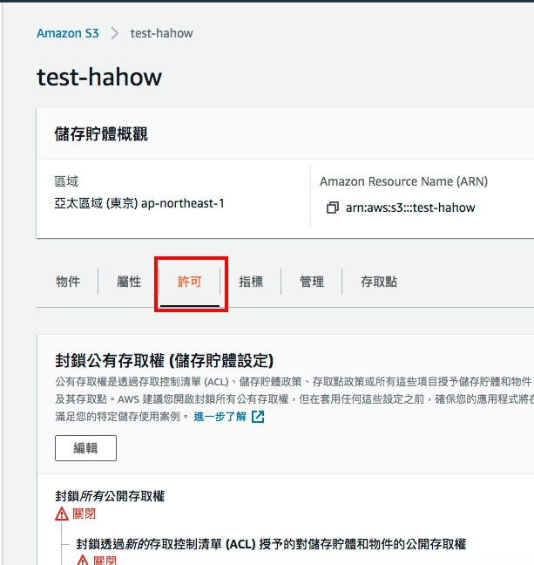

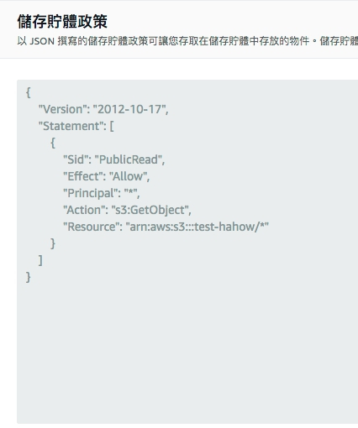

**政策範例**

1. 開放 Bucket 給特定帳戶存取

{

"Version":"2012-10-17",

"Statement":[

{

"Sid":"AddCannedAcl",

"Effect":"Allow",

"Principal": {"AWS": ["arn:aws:iam::111122223333:root","arn:aws:iam::444455556666:root"]},

"Action":["s3:PutObject","s3:PutObjectAcl"],

"Resource":["arn:aws:s3:::*examplebucket*/*"],

"Condition":{"StringEquals":{"s3:x-amz-acl":["public-read"]}}

}

]

}

1. 公開讓所有人讀取

{

"Version":"2012-10-17",

"Statement":[

{

"Sid":"PublicRead",

"Effect":"Allow",

"Principal": "*",

"Action":["s3:GetObject"],

"Resource":["arn:aws:s3:::*examplebucket*/*"]

}

]

}

1. 限制特定 IP 地址無法存取

{

"Version": "2012-10-17",

"Id": "S3PolicyId1",

"Statement": [

{

"Sid": "IPAllow",

"Effect": "Deny",

"Principal": "*",

"Action": "s3:*",

"Resource": "arn:aws:s3:::*examplebucket*/*",

"Condition": {

"NotIpAddress": {"aws:SourceIp": "54.240.143.0/24"}

}

}

]

}

1. 限制特定Domain Name可存取

{

"Version":"2012-10-17",

"Id":"http referer policy example",

"Statement":[

{

"Sid":"Allow get requests originating from www.example.com and example.com.",

"Effect":"Allow",

"Principal":"*",

"Action":"s3:GetObject",

"Resource":"arn:aws:s3:::*examplebucket*/*",

"Condition":{

"StringLike":{"aws:Referer":["http://www.example.com/*","http://example.com/*"]}

}

}

]

}